Where were you when…GEOLOGIC EDITION

The game of “where were you when”, but for geologic time. A basic knowledge of geologic history indicates that where something is now on the earth might not have been where it was, way back when. Let’s find out where West Virginia, with an easily identifiable and distinctive shape, was during some of Earth’s most notable “historic” events.

TARGET AUDIENCE:

* Those interested in geologic history
* Hope to stir some interest in geology and geologic history
* Even those who believe the earth began more recently could find the information interesting and entertaining and possibly provoke some study, research, and respectful dialogue.

KEY POINTS:

* There is more to the rocks below our feet than just something to hold buildings up
* Geology can be both awesome and interesting
* Brief methodology of the plate tectonic model and procedure for map creation
  + GPlates is freeware that can be used to display shapefiles and data in geologic time. Model for this Story Map project is from Christopher Scotese. Imported a shapefile of West Virginia and anchored to his model and projected it “back in time” to various periods. Exported a snapshot out of Gplates, along with present day country outlines, and then imported into ArcGIS online (or Pro) to overlay onto present day maps/layers of interest.
  + Note paleogeography of the time for West Virginia for each time snapshot

LAYOUT/INVENTORY:

* Introduction with geology timeline from USGS
  + <https://pubs.usgs.gov/gip/geotime/time.html>
  + Methodology
* Snowball Earth (640 MYA) map
  + What was Snowball Earth? Or Slushball Earth?
    - Two episodes
  + Include image of Snowball/Slushball Earth (<https://www.nsf.gov/news/news_summ.jsp?cntn_id=116410>)
* First fish (505 MYA) map
  + [Metaspriggina walcotti](http://www.bioone.org/doi/abs/10.1666/06-130.1)
  + Include image of theorized image and fossils
* First land plants (500 MYA) map
  + Green algae 🡪 embryophytes (land plants)
  + 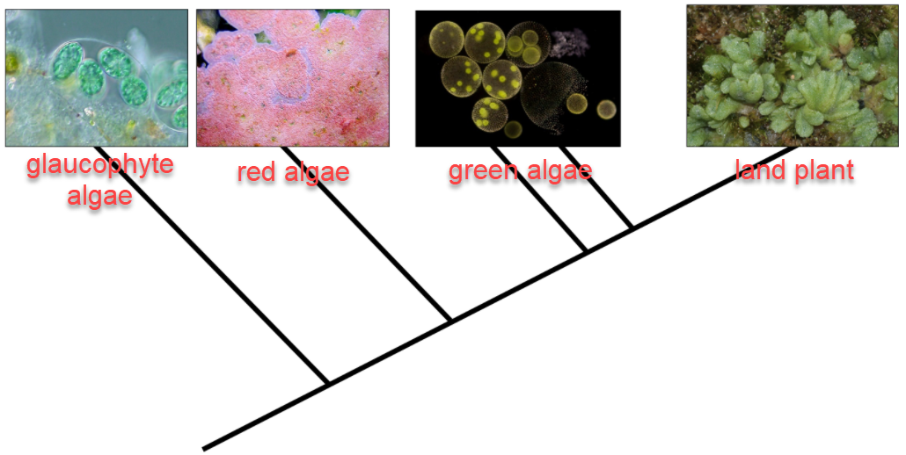

Relationship tree of Kingdom Plantae from Hermsen, 2019. Reproduced for educational purposes only.

* + Include image of theorized image and fossils
* Pangea (250 MYA)
  + What was Pangea? (<https://www.livescience.com/38218-facts-about-pangaea.html>)
* First mammals (225 MYA) map
  + Images and description of first mammals
* Jurassic Period (175 MYA) map
  + What creatures actually lived during the Jurassic? It wasn’t quite Jurassic Park…
    - <https://ucmp.berkeley.edu/mesozoic/jurassic/jurassiclife.html>
  + T Rex (67 MYA) map
* Chicxulub meteor strike (66 MYA) map
  + Include present day location map
  + Explain the event (<https://www.nationalgeographic.com/science/2019/09/last-day-dinosaurs-reign-captured-stunning-detail/#close>)
  + K-T Boundary (<https://www.universetoday.com/39801/k-t-boundary/>)
* Earliest humans (2 MYA) map
  + <https://humanorigins.si.edu/evidence/human-evolution-timeline-interactive>
* End with video capture of Scotese model from 1100 MYA to present
  + Youtube links to his additional videos (<https://www.youtube.com/channel/UCpwbImp13QTi4p1CaQJel1A>)

NOTES:

* Include links to additional resources for further study
* North up, always
* Don’t forget to explain things and keep it relatively basic
* Examples of Gplates model below

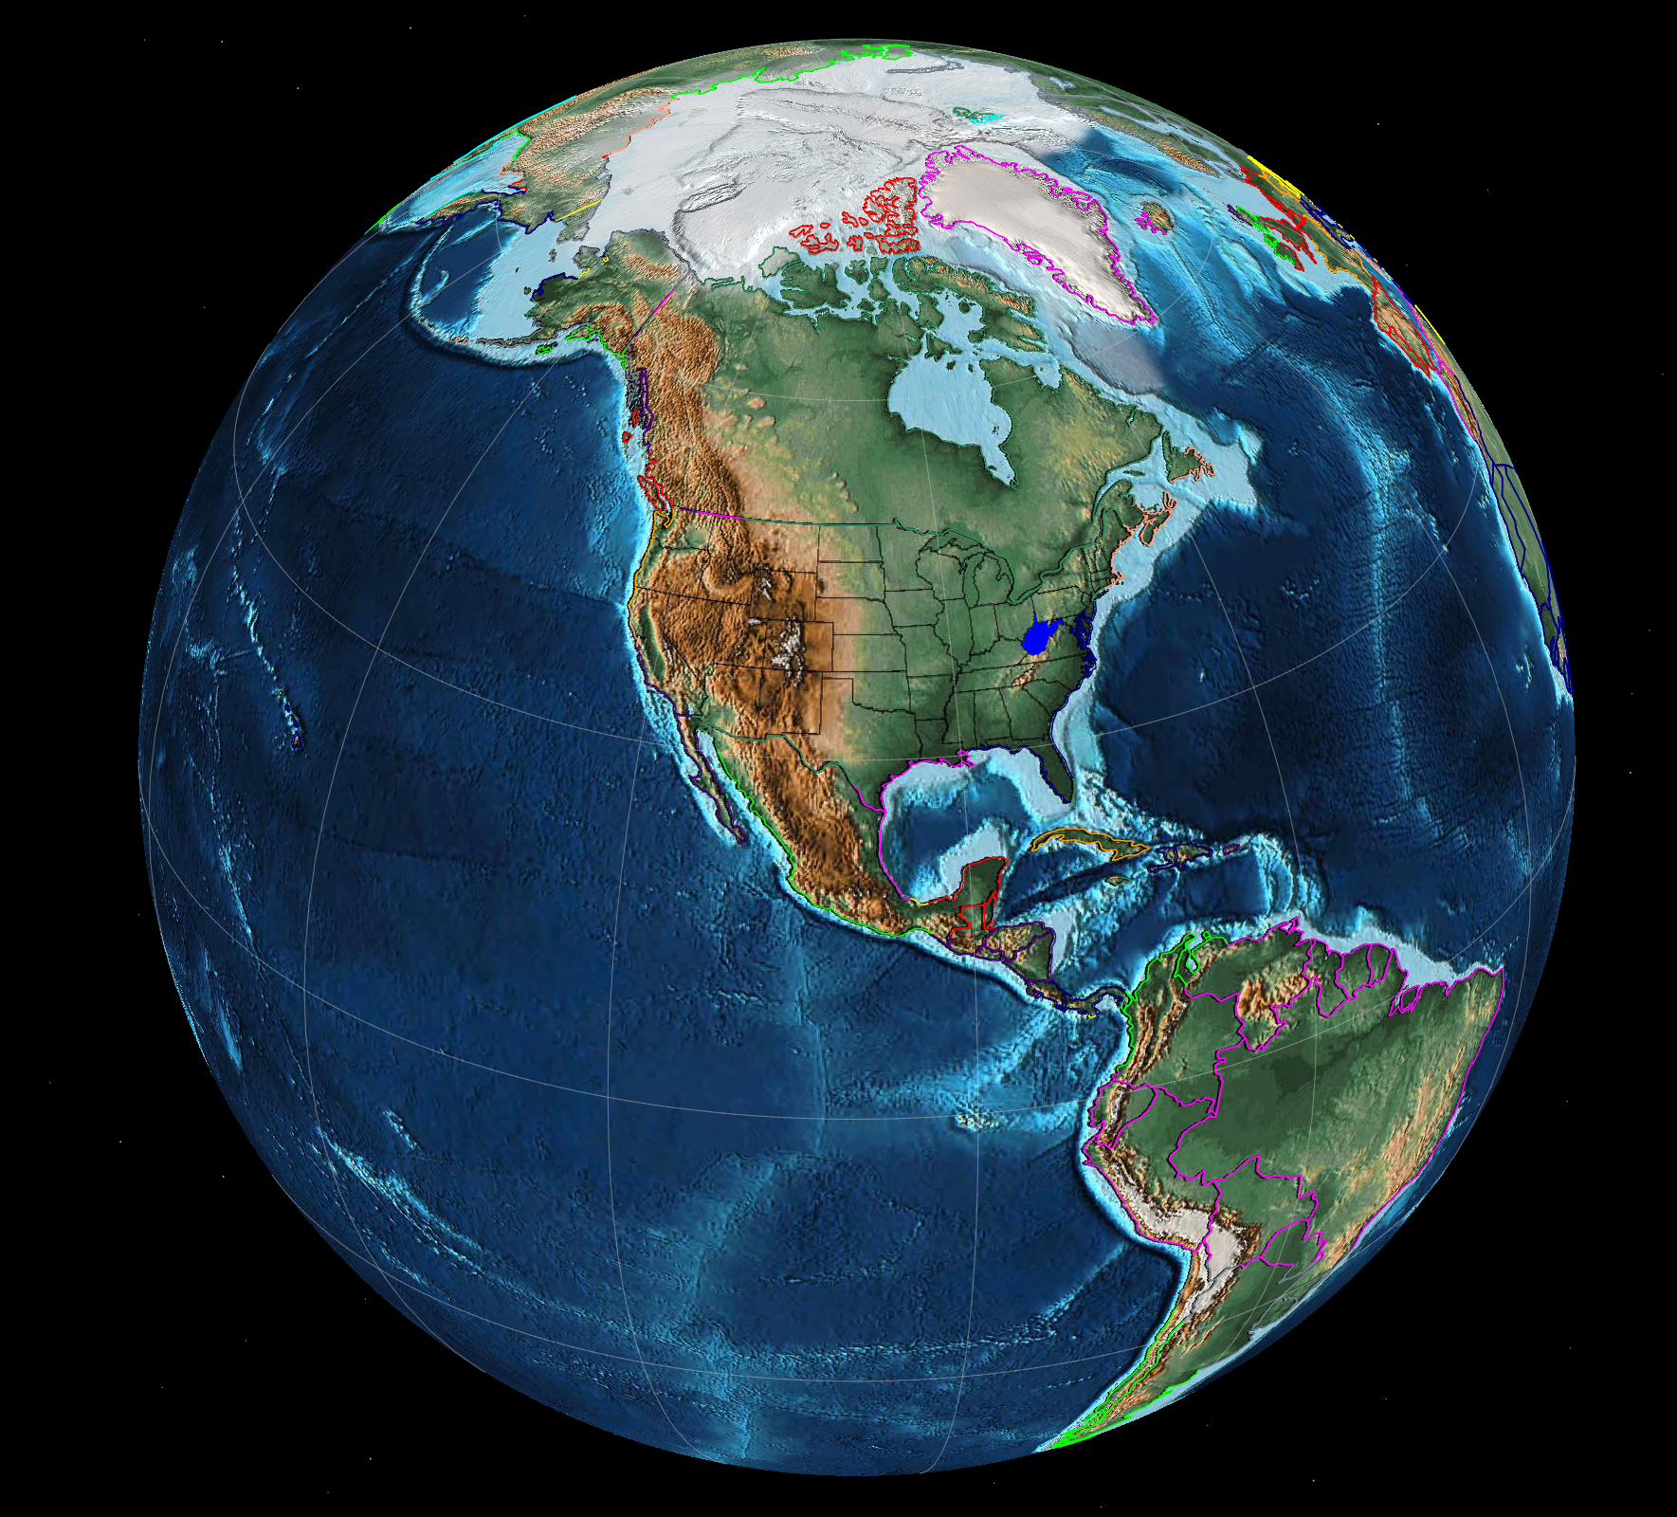

West Virginia (blue) in GPlates, with present day paleogeography and location (paleogeography and plate model from Scotese, 2016).

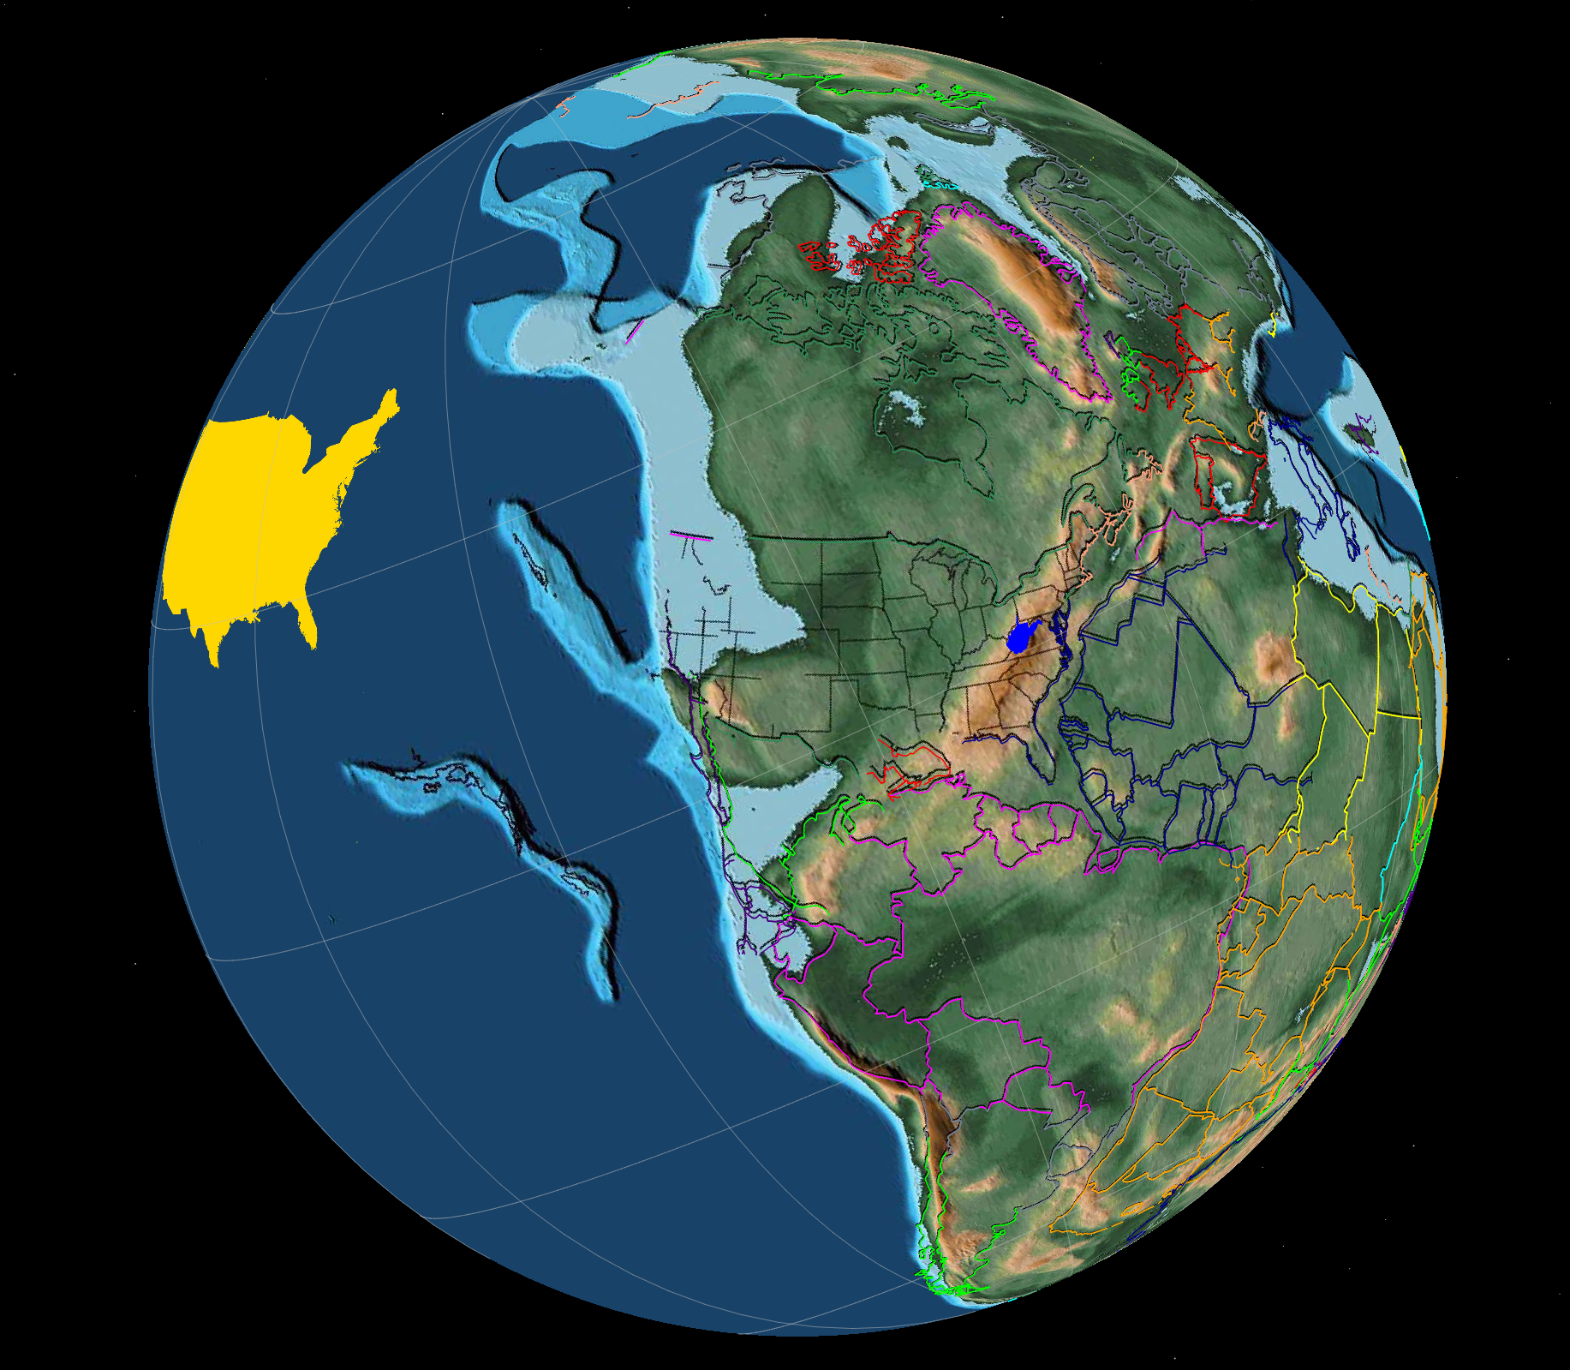

West Virginia (blue) projected back to 250 MYA (million years ago) with paleogeography for that time (paleogeography and plate model from Scotese, 2016). Continental United States (yellow) in current position.

References/Sources:

Allgre, C. and Schneider, S. (July 1, 2005). Evolution of Earth. Retrieved on September 14, 2020, from <https://www.scientificamerican.com/article/evolution-of-earth/>

Becker, B. and Marin, B. (May 2009). Streptophyte algae and the origin of embryophytes. Annals of Botony; 103(7). 999-1004. Retrieved on September 18, 2020, from <https://www.ncbi.nlm.nih.gov/pmc/articles/PMC2707909/>

Black, R. (December 5, 2012). Scientists Discover Oldest Known Dinosaur. Retrieved on September 28, 2020, from <https://www.smithsonianmag.com/science-nature/scientists-discover-oldest-known-dinosaur-152807497/>

Cain, F. (September 10, 2009). K-T Boundary. Retrieved on September 18, 2020, from <https://www.universetoday.com/39801/k-t-boundary/>

Caron, J. (n.d.). Metaspriggina walcotti. Smithsonian Institution – National Museum of Natural History. Retrieved on September 28, 2020, from <https://burgess-shale.rom.on.ca/en/fossil-gallery/view-species.php?id=81&ref=i&>

Deretsky, N. (n.d.) Dynamic Snowball: two long-lived glaciations. Retrieved on September 28, 2020, from <https://www.nsf.gov/news/news_images.jsp?cntn_id=116410&org=NSF>

Geology Page. (February 3, 2013). Appalachian Mountain Range. Retrieved on September 28, 2020, from <http://www.geologypage.com/2013/02/appalachian-mountain-range.html>

Ghose, T. (February 23, 2018). Facts about Pangaea, Ancient Supercontinent. Retrieved on September 18, 2020, from <https://www.livescience.com/38218-facts-about-pangaea.html>

Hermsen, E. (August 30, 2019). Origin of Land Plants. Retrieved on September 18, 2020, from <https://www.digitalatlasofancientlife.org/learn/embryophytes/land-plant-origins/>

Langer, M. et al. (January 12, 2010). The origin and early evolution of dinosaurs. Retrieved on September 28, 2020, from <https://onlinelibrary-wiley-com.ezaccess.libraries.psu.edu/doi/full/10.1111/j.1469-185X.2009.00094.x>

Long, J. (June 11, 2014). The oldest fish in the world lived 500 million years ago. Retrieved on September 18, 2020, from <https://theconversation.com/the-oldest-fish-in-the-world-lived-500-million-years-ago-2771>

Lunar and Planetary Institute. (n.d.). Chicxulub Impact Event. Retrieved on September 14, 2020, from <https://www.lpi.usra.edu/science/kring/Chicxulub/discovery/>

Marshall, M. (February 1, 2012). First land plants plunged Earth into ice age. Retrieved on September 14, 2020, from <https://www.newscientist.com/article/dn21417-first-land-plants-plunged-earth-into-ice-age/#:~:text=The%20first%20land%20plants%20appeared,didn't%20have%20deep%20roots>.

Morris, J.L. et al. (2018). The timescale of early land plant evolution. Proceedings of the National Academy of Sciences of the United States of America, 115(10). Retrieved on September 18, 2020, from <https://research-information.bris.ac.uk/ws/portalfiles/portal/147215235/1719588115.full.pdf>

Morris, S. and Caron, J. (June 11, 2014). A primitive fish from the Cambrian of North America. Nature 512, 419-422. Retrieved on September 28, 2020, from <https://www.nature.com/articles/nature13414>

Müller, R. D., Cannon, J., Qin, X., Watson, R. J., Gurnis, M., Williams, S., et al. (June 21, 2018). GPlates: Building a Virtual Earth Through Deep Time. Geochemistry, Geophysics, Geosystems, 19, 2243-2261. Retrieved on September 14, 2020, from [GPlates: Building a virtual Earth through deep time](https://agupubs.onlinelibrary.wiley.com/doi/full/10.1029/2018GC007584)

National Science Foundation. (March 4, 2010). Scientists Find Signs of “Snowball Earth” Amidst Early Animal Evolution. Retrieved on September 18, 2020, from <https://www.nsf.gov/news/news_summ.jsp?cntn_id=116410>

National Science Foundation. (December 11, 2019). Mass extinction of land and sea biodiversity 250 million years ago not simultaneous. Retrieved on September 28, 2020, from <https://www.nsf.gov/discoveries/disc_summ.jsp?cntn_id=299709&org=NSF&from=news>

Nesbitt, S. et al. (February 23, 2013). The oldest dinosaur? A Middle Triassic dinosauriform from Tanzania. Retrieved on September 28, 2020, from <https://royalsocietypublishing.org/doi/full/10.1098/rsbl.2012.0949>

Panciroli, E. (2017). Fossil Focus: The First Mammals. Palaeontology Online, Volume 7, Article 3. Retrieved on September 28, 2020, from <https://www.palaeontologyonline.com/articles/2017/fossil-focus-first-mammals/>

Pennisi, E. (February 19, 2018). Land plants arose earlier than thought – and may have had a bigger impact on the evolution of animals. Retrieved on September 18, 2020, from <https://www.sciencemag.org/news/2018/02/land-plants-arose-earlier-thought-and-may-have-had-bigger-impact-evolution-animals>

Redd, N. (August 23, 2013). What Was Frigid ‘Snowball Earth’ Really Like? Retrieved on September 14, 2020, from <https://www.space.com/22501-snowball-earth-ice-ages-history.html>

Schirber, M. (August 2015). “Snowball Earth” Might Have Been Slushy. Astrobiology Magazine. Retrieved on September 18, 2020, from <https://www.giss.nasa.gov/research/features/201508_slushball/>

Scotese, C. (April 19, 2016). PALEOMAP PaleoAtlas for GPlates. Retrieved and downloaded on September 14, 2020, from <https://www.earthbyte.org/paleomap-paleoatlas-for-gplates/>

Scotese, C. and Walker, I. (n.d.). What did Earth look like Interactive Globe. Retrieved on September 29, 2020, from <https://dinosaurpictures.org/ancient-earth/#240>

Smithsonian National Museum of Natural History. (n.d.). Human Evolution Timeline Interactive. Retrieved on September 18, 2020, from <https://humanorigins.si.edu/evidence/human-evolution-timeline-interactive>

Smithsonian National Museum of Natural History. (September 22, 2020). Human Family Tree. Retrieved on September 29, 2020, from <https://humanorigins.si.edu/evidence/human-family-tree>

University of California Museum of Paleontology. (n.d.). Jurassic Period: Life. Retrieved on September 18, 2020, from <https://ucmp.berkeley.edu/mesozoic/jurassic/jurassiclife.html>

University of Pittsburgh. (n.d.). Building the Appalachian Mountains. Retrieved on September 29, 2020, from <https://www.pitt.edu/~harbert/penna_geology/events.html>

USGS. (2008) The Geologic Time Spiral. General Information Product 58 – Version 1.1. Retrieved on September 22, 2020, from <https://pubs.usgs.gov/gip/geotime/time.html>

USGS. (August 7, 2012). Historical Perspective. Retrieved on September 28, 2020, from <https://pubs.usgs.gov/gip/dynamic/historical.html>

Walker, J. et al (2018). GSA Geologic Time Scale v. 5.0. Geological Society of America. Retrieved on September 29, 2020, from <https://www.geosociety.org/documents/gsa/timescale/timescl.pdf>

Wei-Haas, M. (September 9, 2019). Last day of the dinosaurs’ reign captured in stunning detail. Retrieved on September 18, 2020, from <https://www.nationalgeographic.com/science/2019/09/last-day-dinosaurs-reign-captured-stunning-detail/#close>

Wellman, C. et al. (September 13, 2003). Fragments of the earliest land plants. Nature 425, 282-285. Retrieved on September 28, 2020, from <https://www-nature-com.ezaccess.libraries.psu.edu/articles/nature01884>

Story Map Links:

<https://storymaps.arcgis.com/stories/1e2f463083024d54b6be04e34569631f>

<https://storymaps.arcgis.com/stories/5920d21eb64f4ba49035f08c7524be7f>